Exhaustive Analysis of Indian Agriculture

* Steps to perform various operations in Power BI Desktop.

Step 1:

* First select the get data option:
* 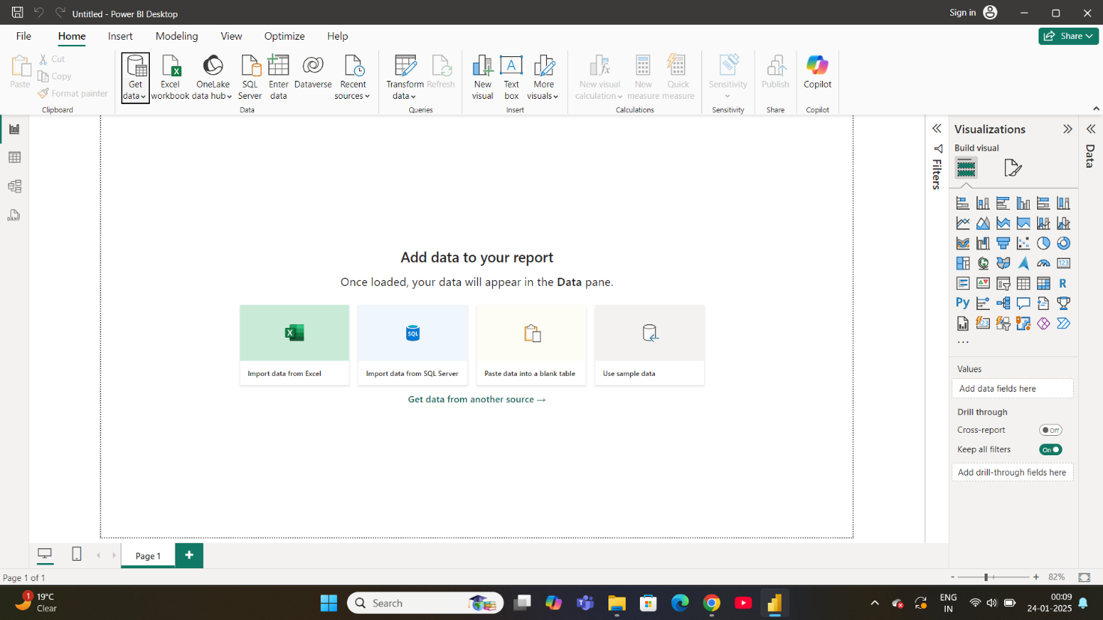

Step 2:

* Then select the Text /CSV to open the data pdf for modification or to apply various operations on it .
* 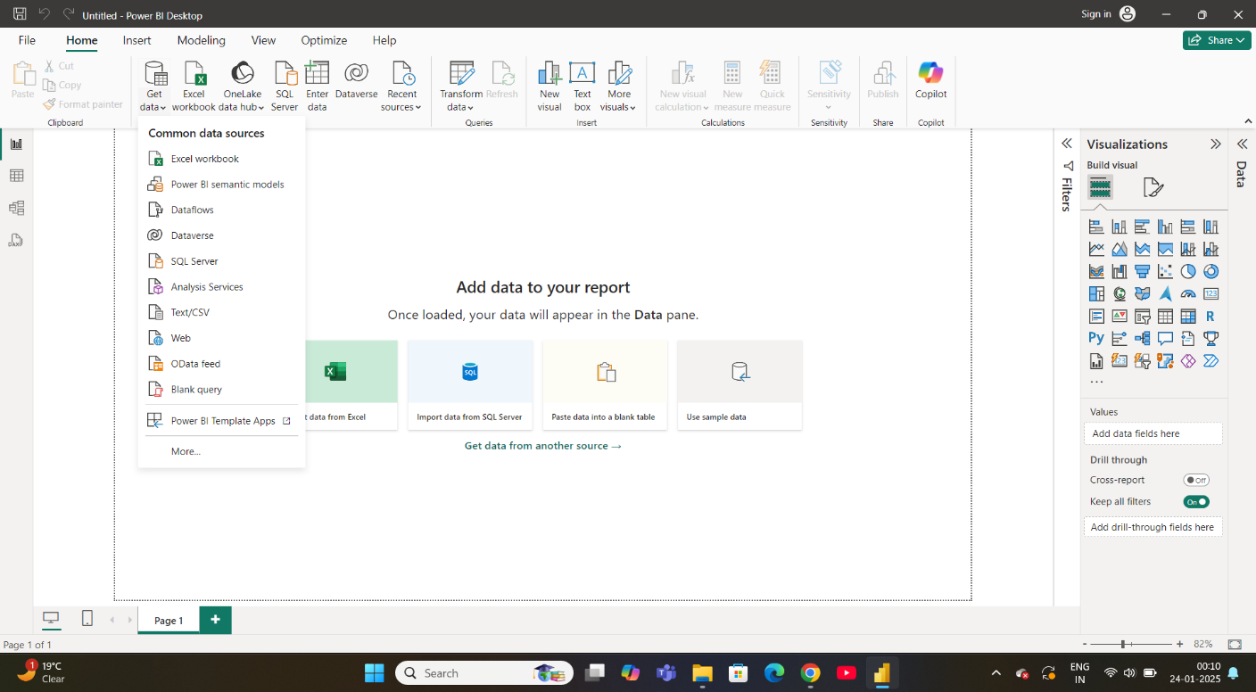

Step 3 :

* Then select the file name , my file name is Exhaustive Analysis of Indian Agriculture.
* 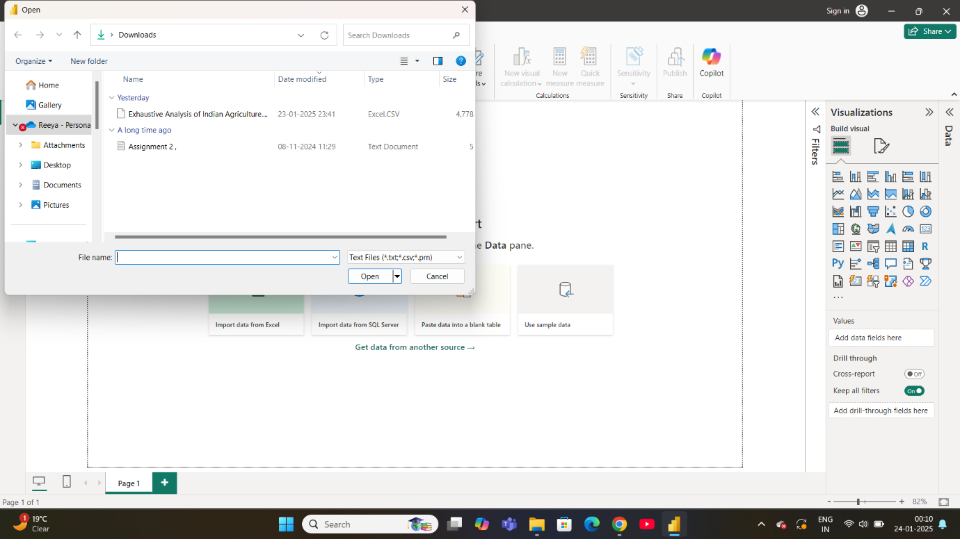

Step 4 :

* After opening the file , Click the Load option within the three options.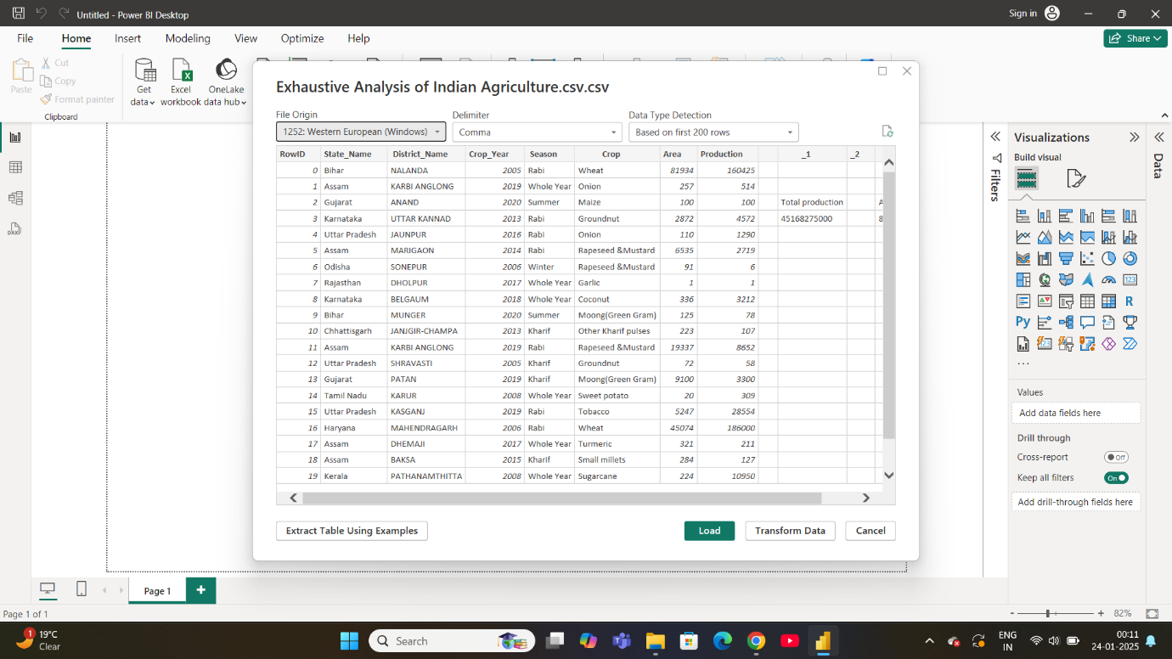

Step 5 :

* After Load the file on Right side of the Window it reflects the name of the File .
* 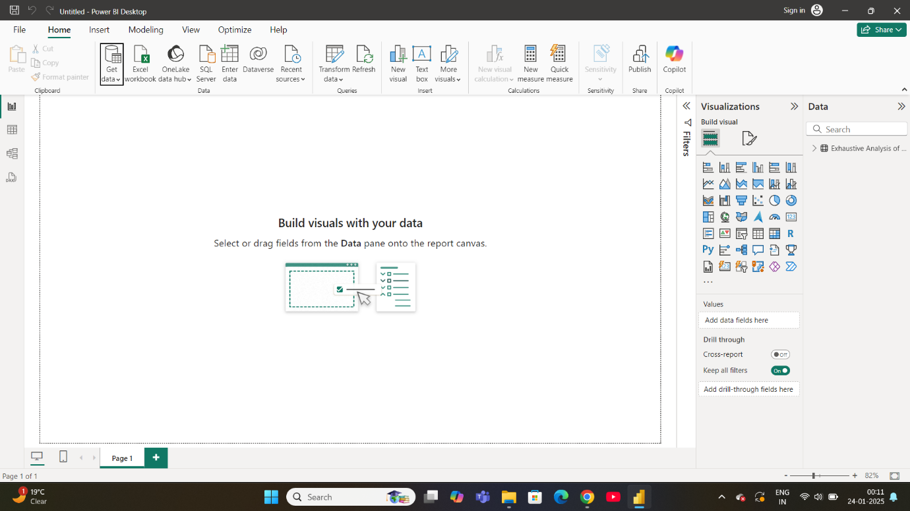

Step 6 :

* After that click on the Transform data then the New Window opens, on that Window we have to perform the Operations.
* 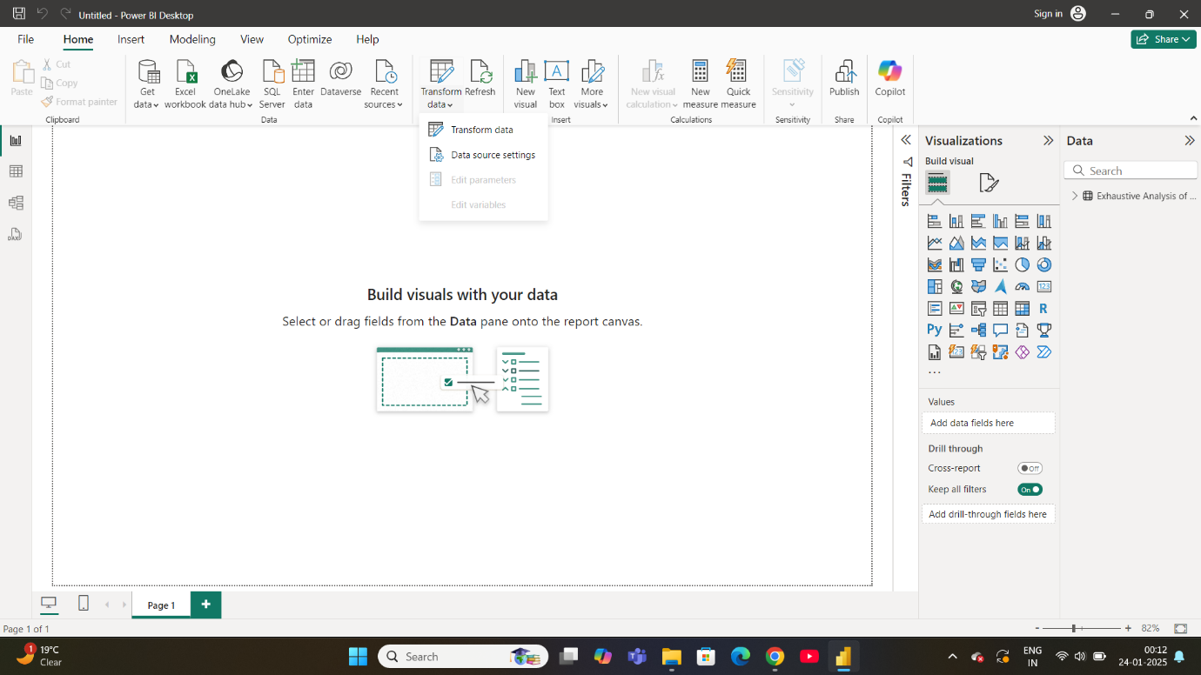
* 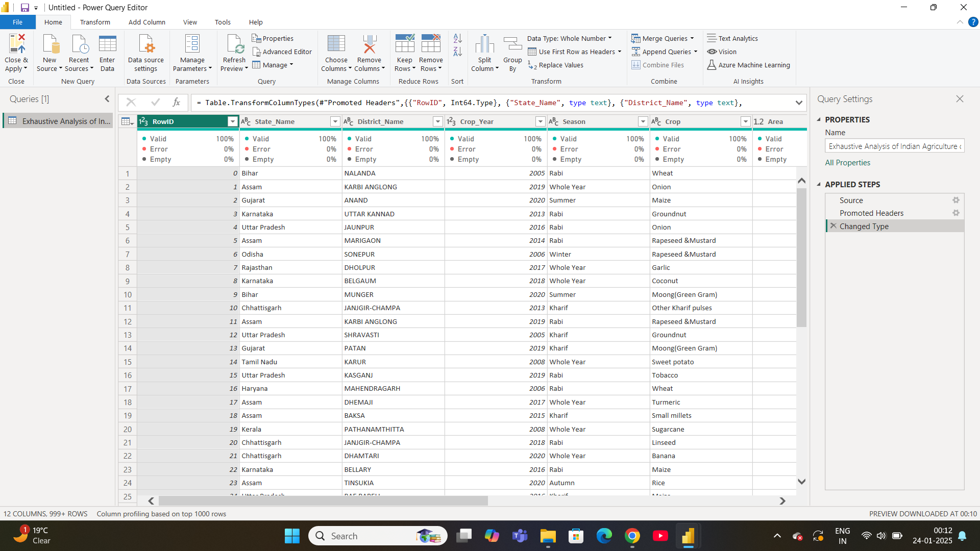

Step 7 :

* Some of the columns are empty so we have to delete it. To delete the column we have to select that column and then right click and click ‘Remove’ .
* 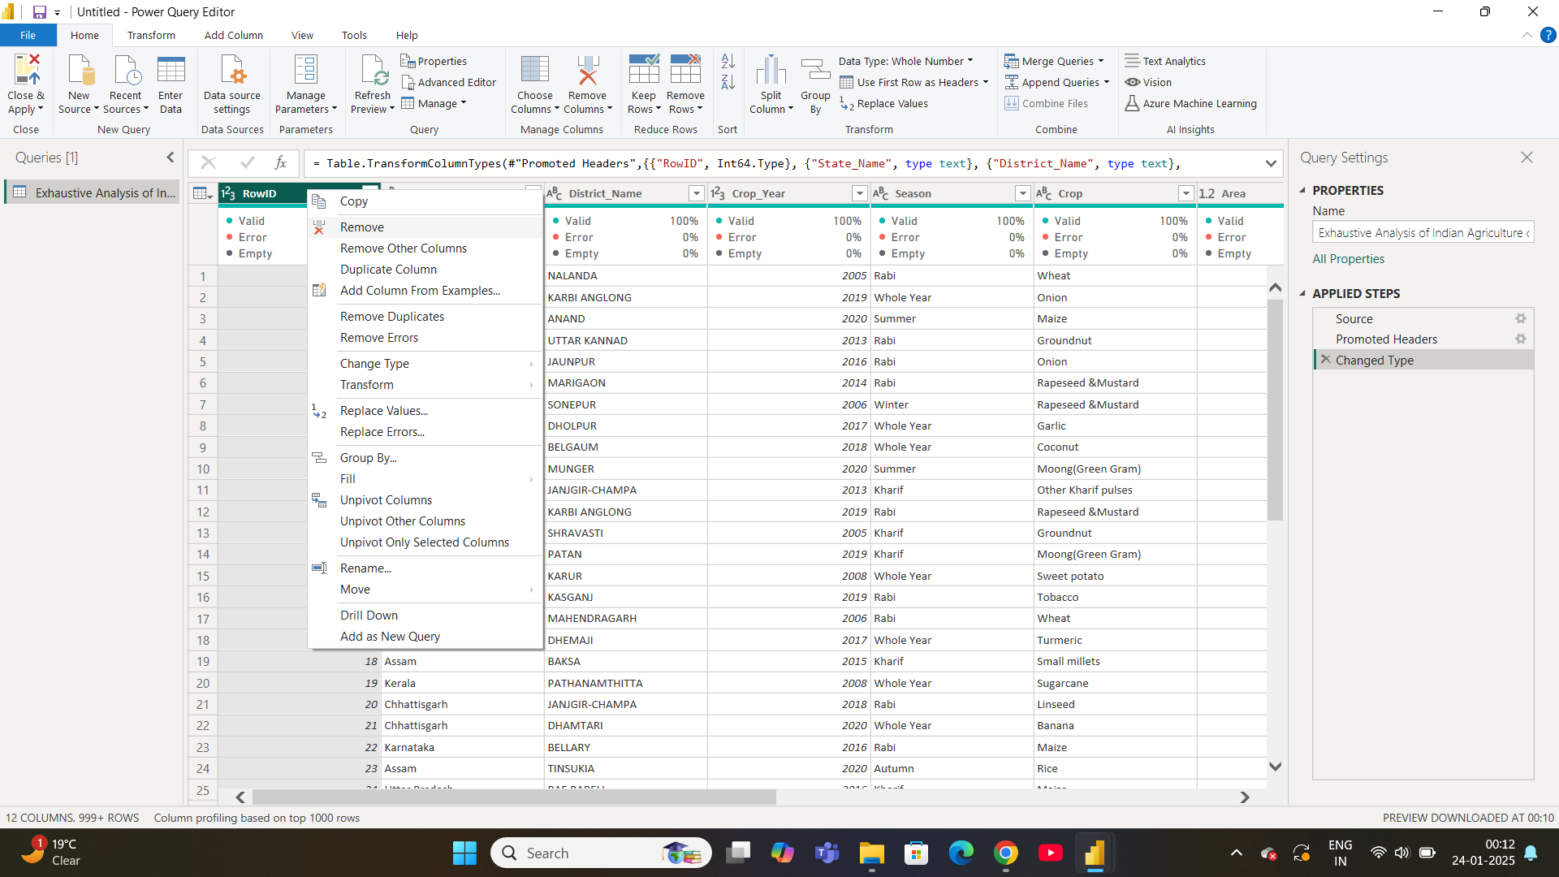

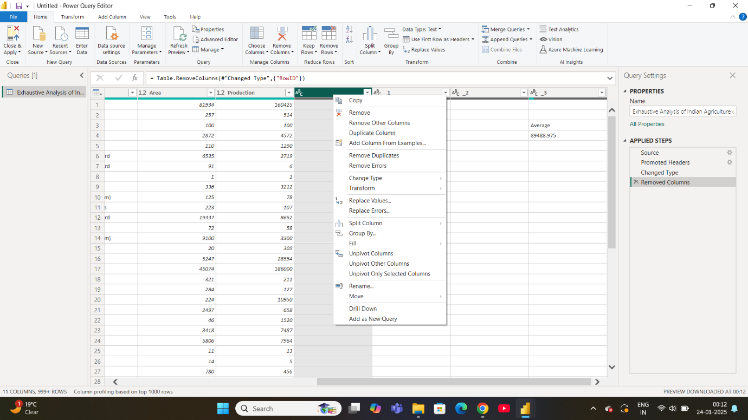

Step 8:

* Most of the times rows also contaion the empty and errors to chech wheather there is error or not click on the ‘View’ and then select the ‘Column Quality’ then below the head row we see the empty or errors.
* 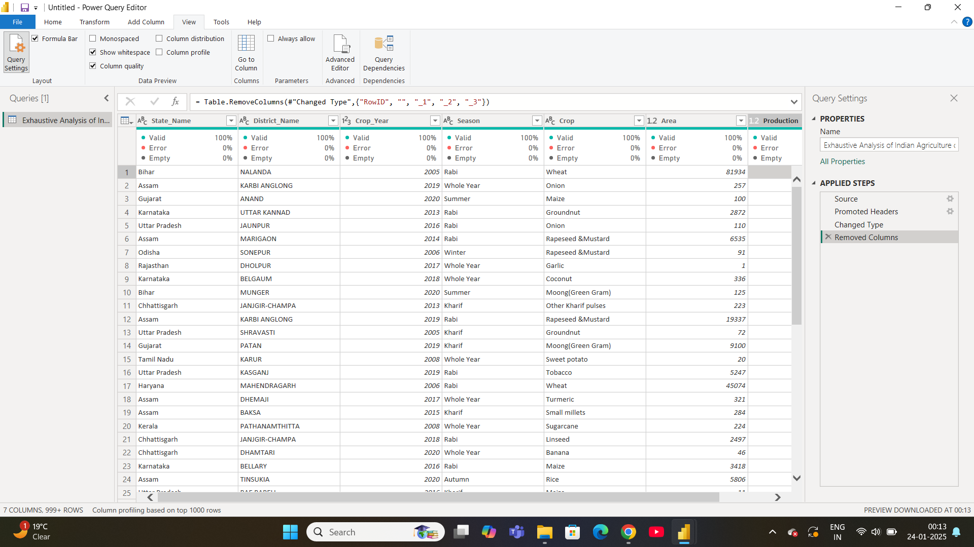

Step 9 :

* After that click on the Close and Apply .
* 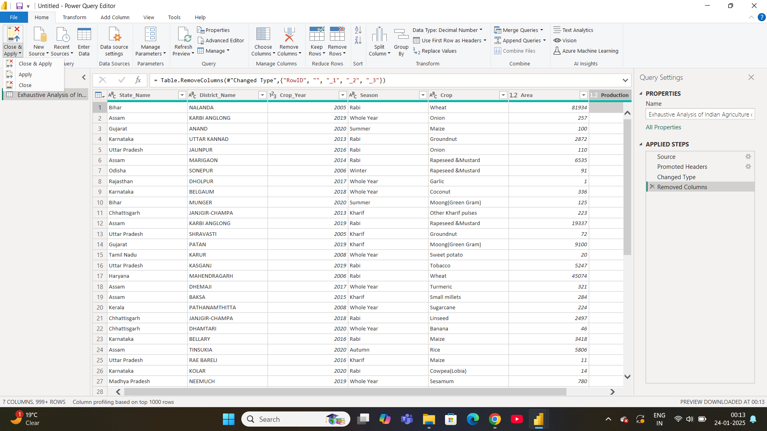

Step 10 :

* Process is done all operations are done then final window looks like .

